**ECEN 4303 Digital Integrated Circuit Project Report**

from Electrical and Computer Engineering Department

**Students’ Name**

Jishuo Li and Alan Chim



Oklahoma State University

Stillwater, OK 74078, USA

**Abstract**

8-bit binary multiplier is widely used in any microcontroller and mainframe. It is designed to speed up arithmetic calculation when multiplier-related task is given, so that a system can run significant faster when specified tasks are given. Our objective is to design 8-by-8 bit multiplier, and return a result with 16-bit binary number.

**Introduction**

8-bit binary multiplier is an electronic circuit used in digital electronics, such as computer and microcontroller, to multiply two 8-bit binary numbers.[1] It is designed using binary full adders, multiplexers, D flip-flop, and some other gates. The theory design behind it is to produce eight partial product by performing eight one-bit multiplications, one for each bit in multiplicand. To produce the product, all eight partial products are needed to add up to produce unsigned 16-bit product.[2]

Full adder is a digital logic circuit in electronics that implements addition of numbers.[3] It is designed using XOR gates, AND gates, and OR gates to produce desired output. The theory design behind it is to pass through two input bits into XOR and the result is XOR with previous carry in bit, at the same time, AND both steps to determine carry out bit, so that the output can be determined.

The D flip-flop tracks the input, making transitions with match those of the input. The input is a data line; the flip-flop stores the value that is on the data line. It can be thought of as a basic memory cell.[4] The objective of D flip-flop is to control the timing of the output, since the result is clocked in this project.

In electronics, multiplexer (or mux) is a device that selects one of several digital input signals and froward the selected input into a single line. A mux of inputs has select lines, which are used to select which input line to send to the output.[5]

**Theory**

8-bit binary multiplier requires the following main components to work as intended:

1. Full adder
2. Multiplexer (mux)
3. D flip-flop

When initial value is passed in the full adder, each time the value is left shifted to perform addition and compared with the multiplicand to ensure the shifted value is required or not, which can be selected by multiplexer. D flip-flop is introduced to ensure the processes are clocked, so that the additions are performed sequentially. Since the project is designing an 8-bit binary multiplier, therefore the process has to be repeated for 8 times.

The theory can be optimized on the magic and schematic design, as any minor thing, such as the length of wire connection between modules, could impact the overall performance.

**Design**

Schematic of 8-bit binary multiplier is essential as it can tell whether the design of the datapath whether is true or not. To build an 8-bit binary multiplier in a better way, multiple modules that connect together into one piece is the initial plan. The multiplier is being modeled into full adder, inverter, multiplexer, D flip-flop, and AND gate.

Since all the schematics are given at the beginning of the project day, designing schematics can be skipped, and examine all schematics in SUE format. Top-level schematic is shown below:

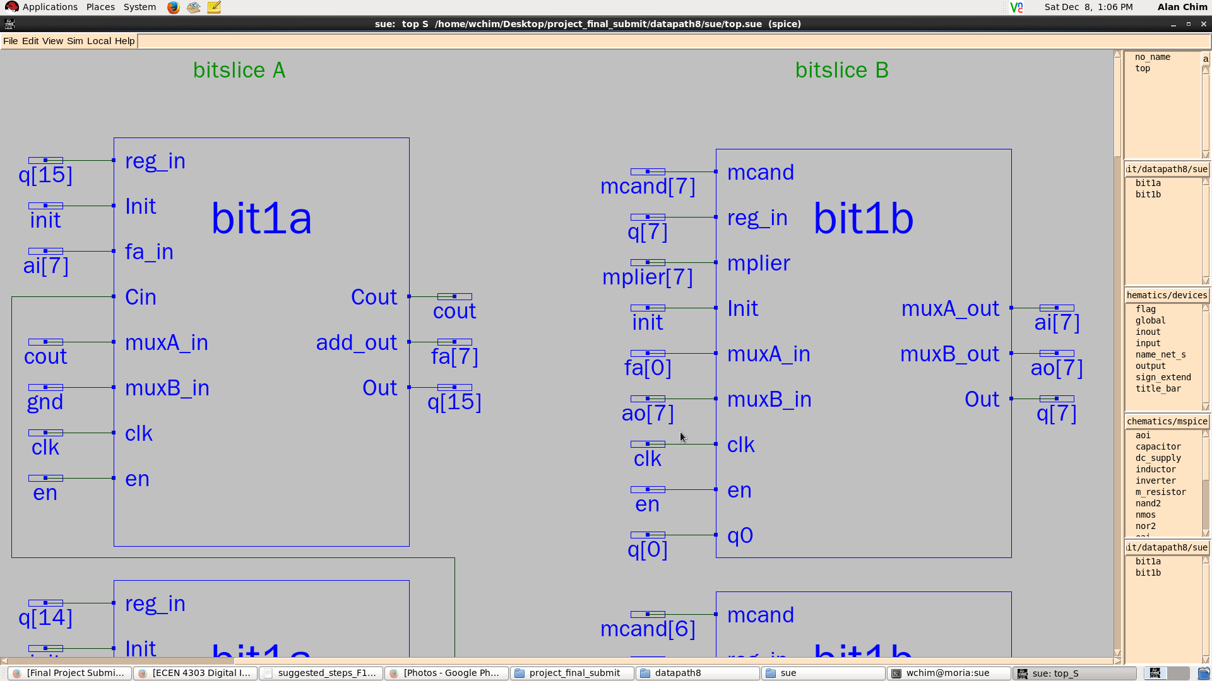  
Schematic above shows one-bit model in 8-bit binary multiplier

After perform examination, stick diagrams for each schematic are definite important diagrams for designing the MAGIC file of the multiplier. Stick diagram can visualize the design of a MAGIC and it is easy to spot the error on stick diagram rather than on MAGIC file. Hence, all stick diagrams must be done in this step. All required stick diagrams are shown below:

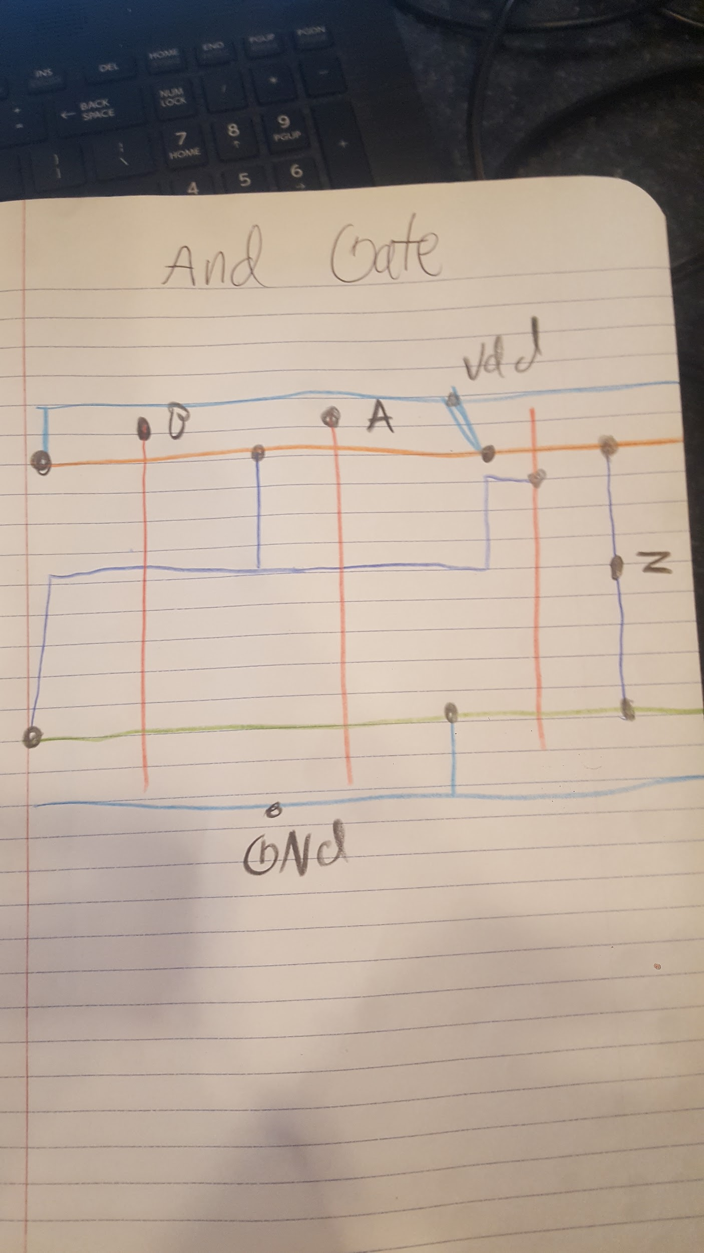  
Photo above shows the stick diagram of AND gates

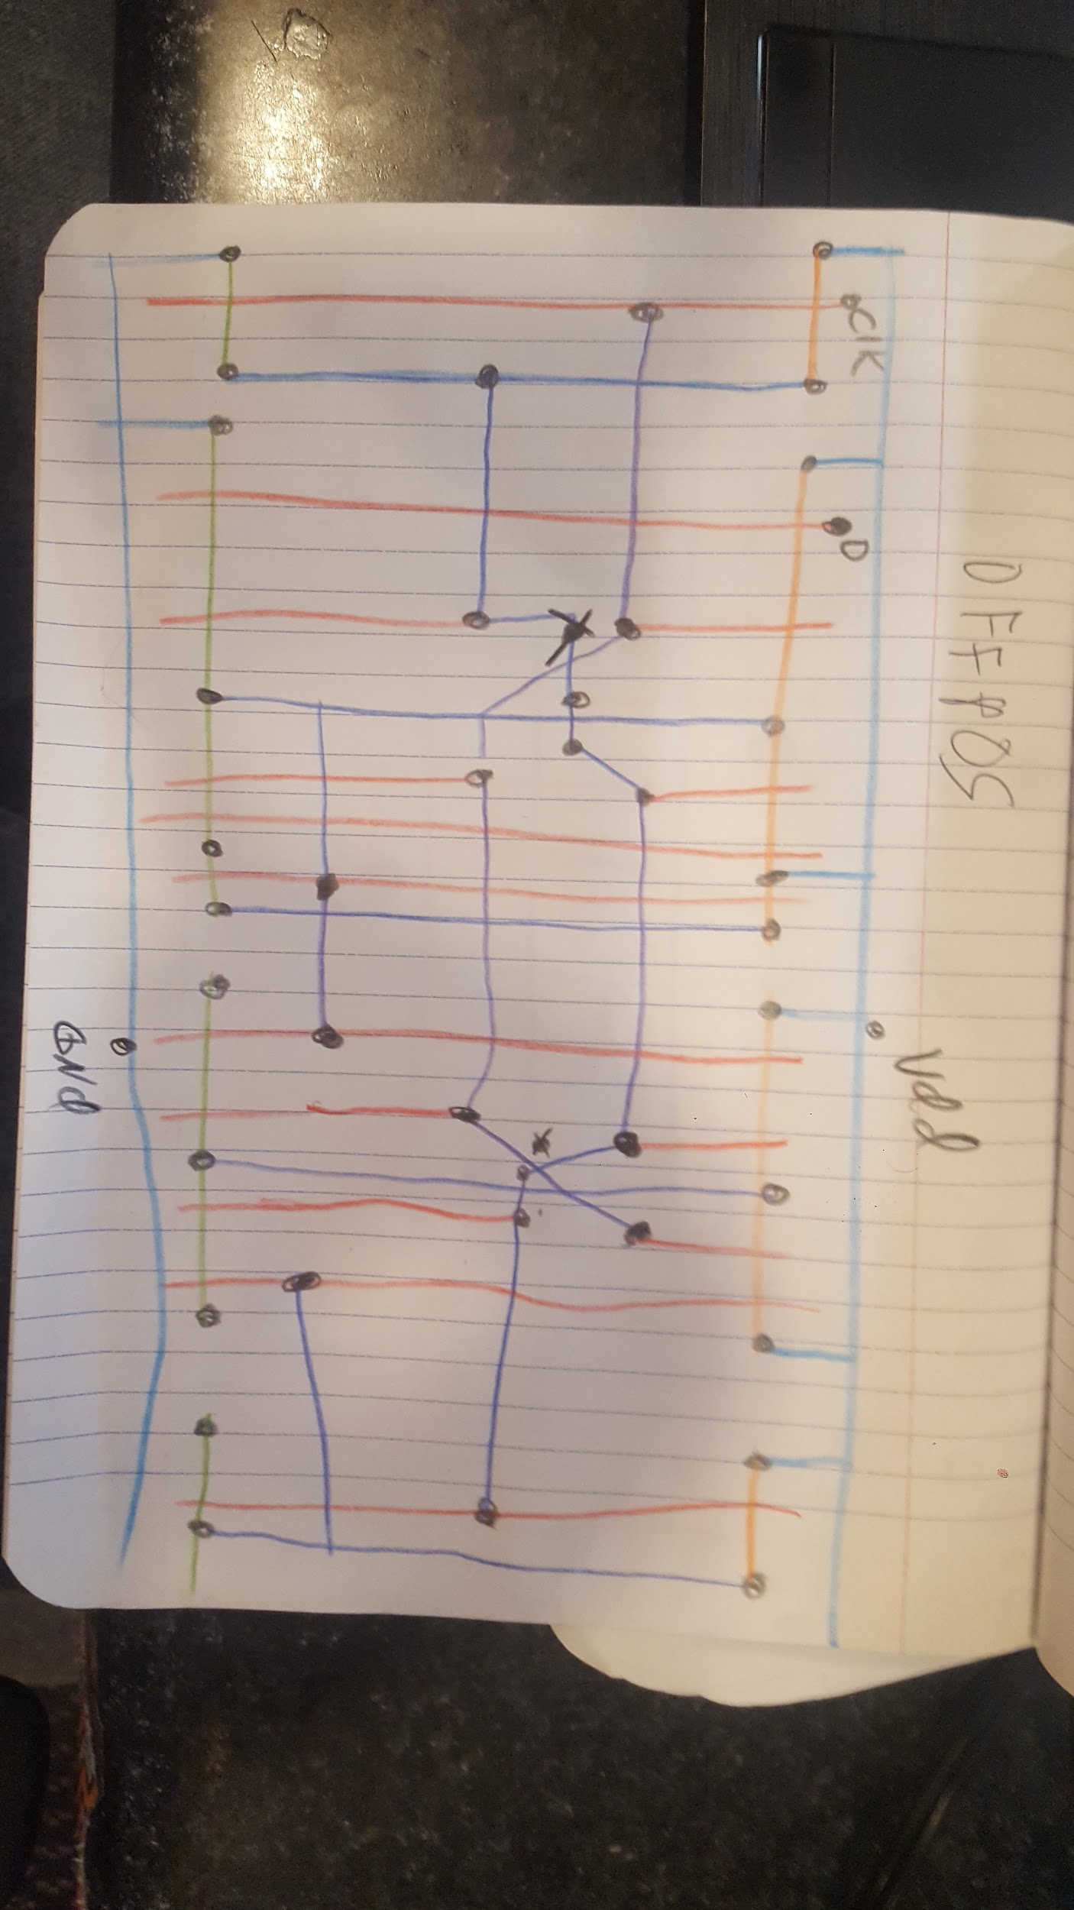  
Photo above shows the stick diagram of D flip-flop

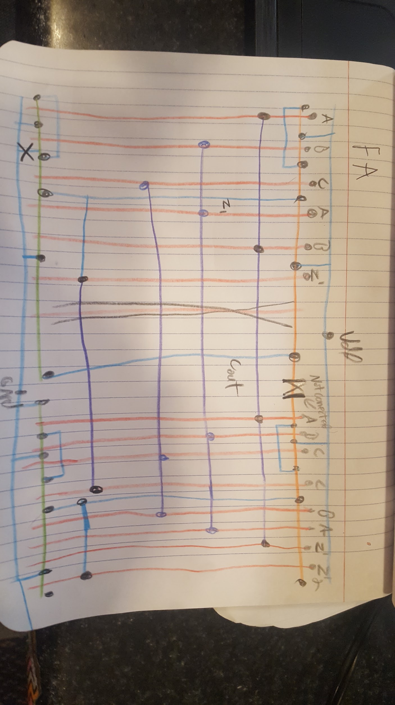  
Photo above shows the stick diagram of Full Adder

Only three stick diagram are displayed as minor components in the design are provided at the beginning of the project day, including MAGIC, SUE, and LVS. Hence, no stick diagram is required for other components.

In this stage, designing full adder and D flip-flop are much difficult than the others, as they contain multiple input gates are connected to each other outputs. When designing the MAGIC file of D flip-flop, the clock circuit is connected to each group of gates that required metal connection to “fly-over” another metal connection. This step requires cautious measurement when “fly-over” metal connection as both *metal1* and *metal2* are not recommended to place on top of each other in a parallel way when connecting different gates, although they are technically not connected and do not violate the design law. Besides, spacing between group of CMOS must be considered for metal connection between group of CMOS can be designed optimally.

All MAGIC files are designed based on their individual stick diagram. To ensure MAGIC files are working properly, each MAGIC file has to be LVS with Calibre.

**Result**

The following shows the screenshot of all MAGIC files that designed by us:

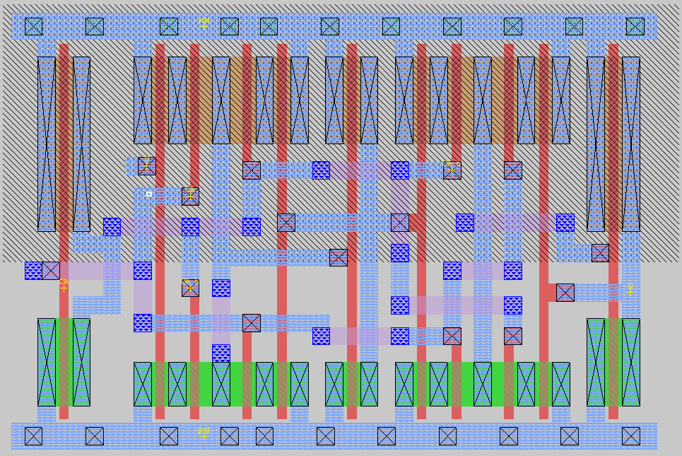  
Screenshot above shows the MAGIC layout of 1-bit D flip-flop (filename: dffpos.mag)

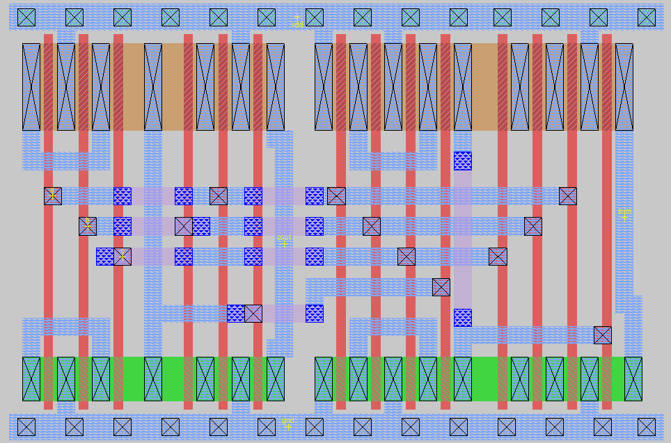  
Screenshot above shows the MAGIC layout of 1-bit Full Adder (filename: FA.mag)

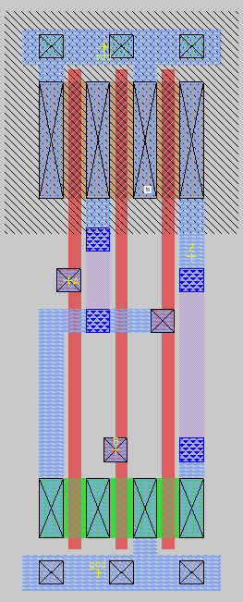  
Screenshot above shows the MAGIC layout of AND Gate (filename: an.mag)

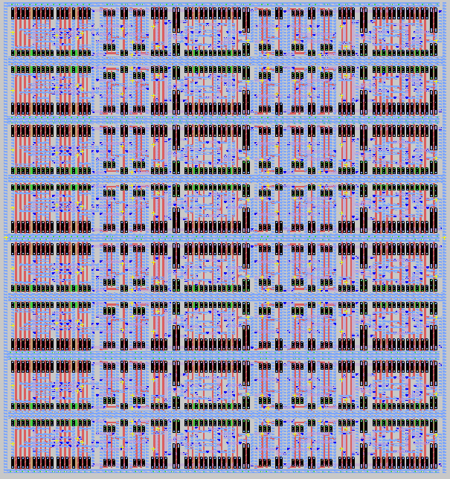  
Screenshot above shows the MAGIC layout of 8-bit binary multiplier (filename: top.mag)

Due to the time issue, we do not complete any Verilog section and HSPICE section.

**Conclusion**

The project taught us the significance of multipliers in every day computers and how challenging it is to create such devices in the real world. We take for granted the technology in front of us every day without releasing the amount of hours that where put in just to make a multiplier on your computer. There are hundreds of other things that must be made correctly too just for something like a cellphone to work correctly. This also has taught us real world experience in designing, creating, and testing circuitry. Though this project was extremely challenging, we learned a lot.

**References**

1. “Binary multiplier”, *Wikipedia, The Free Encyclopedia*, n.d., <https://en.wikipedia.org/wiki/Binary_multiplier>
2. “Binary multiplier”, *Wikipedia, The Free Encyclopedia*, n.d., <https://en.wikipedia.org/wiki/Binary_multiplier>
3. “Explain Half Adder and Full Adder with Truth Table”, *Elprocus - Electronics | Projects | Focus*, n.d., <https://www.elprocus.com/half-adder-and-full-adder/>
4. “The D Flip-Flop”, *HyperPhysics*, n.d, <http://hyperphysics.phy-astr.gsu.edu/hbase/Electronic/Dflipflop.html>
5. “Multiplexer”, *Wikipedia, The Free Encyclopedia*, n.d., <https://en.wikipedia.org/wiki/Multiplexer>